**Influxdb2 server can be managed using localhost:8086**

Just open up a browser and type localhost:8086 in the address bar.

If you see this, it means you have start the influxdb service / server

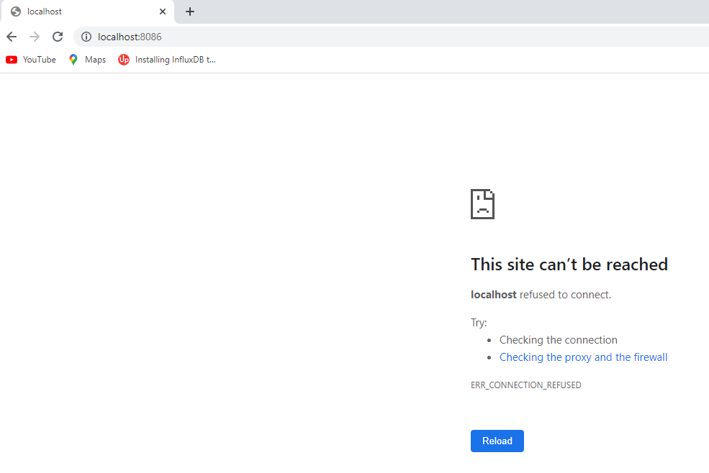

Head over to the folder where you have influxd.exe and launch it.

Assuming you have it in C:\Influxdb2 folder.

Cd to this folder cd c:\influxdb2

C:/influxdb2> **influxd**

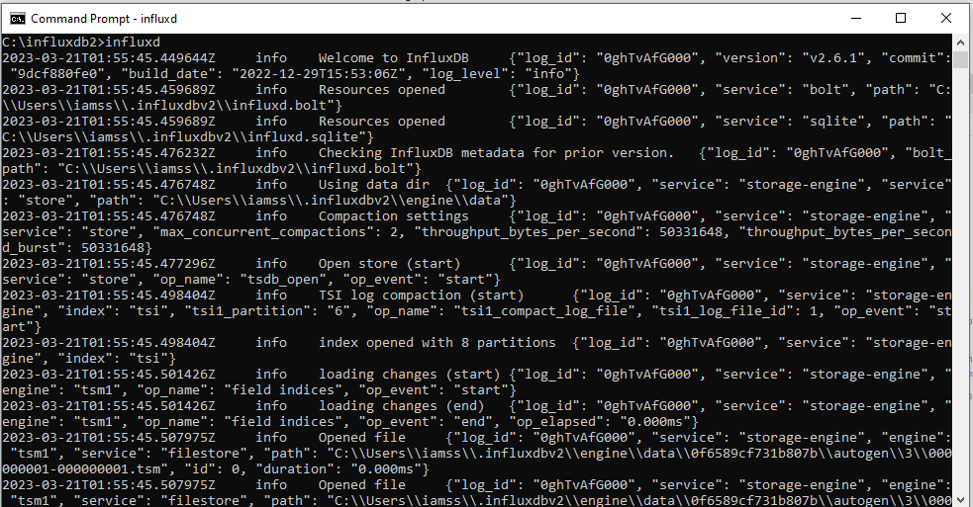

Once you see this, it means the services has started. Now enter [**http://localhost:808**](http://localhost:8080)**6** to the browser address bar. You will now see InfluxDB2 server admin page on your screen